Case Study 8: Password Policy Validation

1. Problem Statement
Check whether a sample password has at least eight characters and contains both a letter and a digit.

2. Objectives
- Check password length.
- Check for letters and digits.

3. Assumptions
- This is a basic classroom exercise, not a complete security checker.
- The program does not save the password.

4. Algorithm
1. Read a sample password.
2. Check its length.
3. Loop through characters to find a letter and a digit.
4. Display whether it meets the sample rules.

5. Flowchart
START → Read sample password → Check length → Check letters and digits → Display valid or invalid → STOP
For a drawn flowchart, use: oval for START/STOP, parallelogram for input/output, rectangle for calculations, and diamond for decisions.

6. Pseudocode
READ password
SET letter = False, digit = False
FOR each character: check isalpha and isdigit
IF length >= 8 AND letter AND digit: DISPLAY valid
ELSE DISPLAY invalid

7. Python Source Code
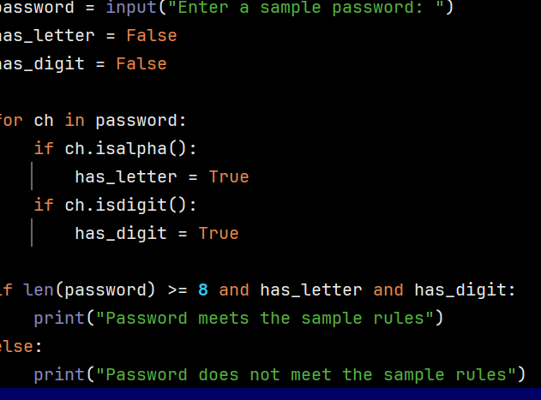

8. Test Cases
Test 1: student123 → meets rules. Test 2: abc12 → does not meet rules.

Sample Output
Input: student123
Output: Password meets the sample rules

9. Conclusion
The program practices strings, loops, and conditional statements.

